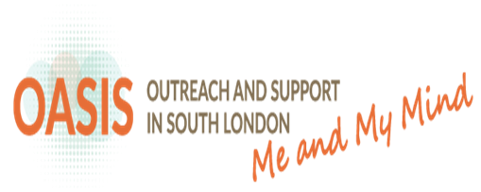

Advice, support and treatment for young people

Lewisham Croydon Southwark Lambeth
www.meandmymind.nhs.uk

Who are we?
OASIS is a health service offering assessment, talking therapies, and practical support for young people who have unusual experiences which are having a negative impact on their lives.
Our aim is to reduce the risk of difficult experiences becoming worse, and to improve peoples’ wellbeing. We hope to help people get their lives back on track and reach their potential.

Our service is made up of a Team Leader, Doctors, Clinical Psychologists, social worker and a Mental Health Nurse.
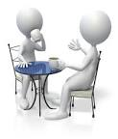

What we offer:

- A careful and detailed assessment of what you have been going through
- Psychological therapy specifically tailored to you
- Coping strategies to help make sense of and manage difficult experiences
- Practical advice around housing, and benefits that you may be entitled to
- Support in taking up new opportunities to get back into work or study.

Who do we help?

Young people between 14 and 35 living in
South London, (if under 18 then under care of camhs) who have been experiencing any of the following:
- Unusual experiences like seeing or hearing things that other people can’t.
- Constantly thinking about particular ideas or beliefs
- Feeling that things and people seem strange or unreal
- Confused or muddled thinking
Disturbances in thoughts, feelings and how we see the world can be confusing and distressing. Many people have experiences that can be difficult to make sense of. These can lead to a person feeling anxious, irritable and depressed. A person may prefer to spend time alone or struggle with education and work.
These changes can occur for a number
of reasons, build-up of stress,
adjusting to a new environment,
physical health problems, or drug and
alcohol use. Sometimes these
experiences can also be early signs
of a mental health problem.

If you have a family history of a
close relative (mum, dad, sibling) with a mental health problem and have concerns about yourself, please get in touch.
Contact us:

We are open Monday to Friday, 9am -5pm.
___________________________________

For OASIS Lewisham please contact us at:

59 Cordwell Road
London SE13 5QY

Tel: 0203 228 9238| Fax: 0203 228 5846
E-mail: oasis_croydonandlewisham@slam.nhs.uk
___________________________________

For OASIS Croydon please contact us at:

Queens Resource Centre
66a Queens Road
Croydon CR0 2PR

Tel: 0203 228 5800| Fax: 0203 228 5846
E-mail: oasis_croydonandlewisham@slam.nhs.uk
___________________________________

Travel

For the quickest way to plan your journey to a SLaM service try TFL’s journey planner.

TFL 24hr travel information: 0207 2222 1234
www.tfl.gov.uk/journeyplanner

Visit the OASIS website for further information:
www.slam.nhs.uk/oasis.

Useful Contacts:

MIND
Support for anyone worried about their own mental health or someone else’s.

Tel: 0300 123 3393
www.mind.org.uk

Samaritans
Offers confidential emotional support to anyone in crisis. Open 24hrs a day 365 days per year.

Tel: 08457 909090
www.samaritans.org

Rethink
Support and advice for people with mental health difficulties, their families and carers.

Tel: 0300 5000 927
www.rethink.org

Time to Change
An organization working to prevent discrimination and stigma around mental health.

Tel: 0208 215 2356
www.time-to-change.org.uk

Carers UK
Provides information and other kinds of help for carers.

Tel: 0808 808 7777
www.carersuk.org

If you’d like a large print, audio, Braille or a translated version of this leaflet then please ask us.
_______________________________

Contact SLaM

SLaM switchboard: 0203 228 6000
SLaM website: www.slam.nhs.uk

24 HOUR MENTAL HEALTH CRISIS LINE

0800 731 2864

PATIENT ADVICE AND LIASION SERVICE (PALS) is an independent service here to listen and support you in whatever way they can to ensure your experience at SLaM is a positive one. If you are not happy with something at SLaM then PALS will try to help you and can advise on the complaint process

PALS 24hr information line: 0800 731 2864
PALS website: www.slam.nhs.uk/pals
PALS email: pals@slam.nhs.uk

